### CS-639 Building User Interfaces, Fall 2019, Professor Mutlu

# Assignments — Week 10 | Design | Mobile Microinteractions

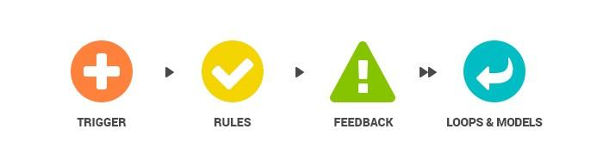[1]

f

**Step 1. Analyze a microinteraction.** In this step, you will find an existing microinteraction used in a mobile app or a wearable device app from any domain (not just calorie tracking). Capture screenshots of the microinteraction and annotate the screenshots to identify and describe triggers, rules, forms of feedback, loops, and modes *(find at least one of each)*. If the microinteraction occurs very briefly and taking screenshots is challenging, you may have to capture a video recording of the microinteraction, from which you can gather still images. (See guides for screen recording on [iOS](https://support.apple.com/en-us/HT207935) and [Android](https://android.gadgethacks.com/how-to/enable-built-screen-recorder-android-10-0194955/).) Be sure to investigate whether application or global modes change the behavior of the microinteraction. For example, “do not disturb” can affect the behavior of many microinteractions. After your analysis and annotation, discuss the design choices for the microinteraction in a brief paragraph or two. For example, is this an appropriate or effective form of feedback for this microinteraction? If not, what would be more appropriate or more effective? Could the microinteraction fail under different modes? If so, how would you address that?

<annotated-screenshots-of-microinteraction>

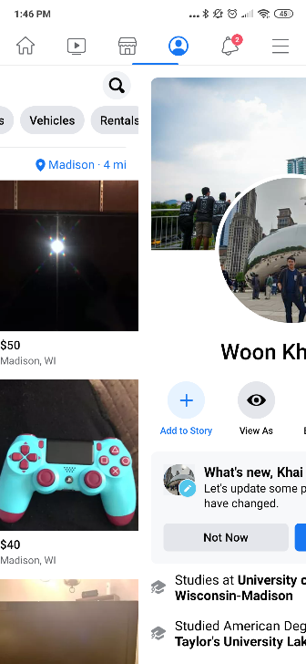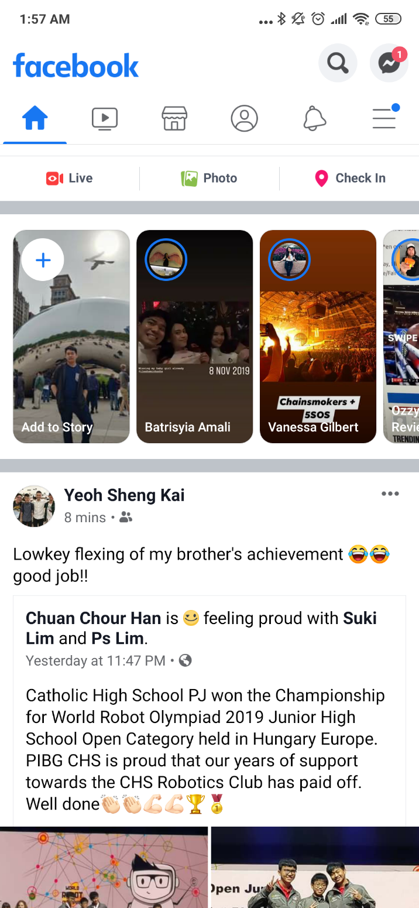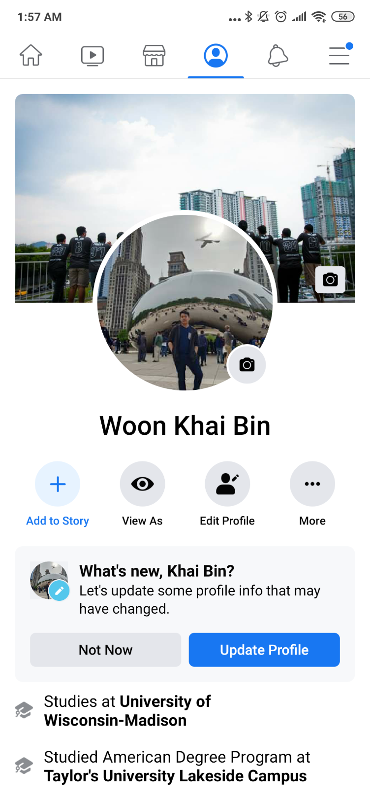

Feedback

Rules

Modes

<discussion-of-design-choices>

Trigger: Pressing the respective tab/ swiping left/right with a finger

Rules: switches “Views” or pages or modules

Feedback: The bar below the tabs slides across to indicate change of context. Selected tab is highlighted. Pages are also slid across the screen to show movement.

Loops & Models: When moved to the home tab, the tab bar gets pushes down to show the logo, search and chat functionality

**Step 2. Design a microinteraction.** In this step, you will design a new microinteraction in the calorie tracking domain. You may or may not be able to implement your design in this part of the assignment in your React Native 3 deliverable, so you do not have to limit your design to what you can implement. You can choose a tablet computer, a phone, or a watch (or all) as the target platform for your microinteraction, and you are encouraged to fully utilize specific platform capabilities (e.g., Apple Watch crown, multitouch on a mobile/tablet screen). Describe the functioning of your design in a storyboard, using 3-6 scenes. (You can use the [NN/g storyboard template](https://www.nngroup.com/articles/storyboards-visualize-ideas/).) The storyboard can be pasted below or attached to the final PDF. You will next create hand-drawn or digitally created wireframe(s) of the screen(s) that the user will see while interacting with the microinteraction and annotate them to highlight the trigger, rule, and feedback and to describe loops and modes *(identify at least one of each)*.



1. [Image source](https://medium.com/nyc-design/what-is-micro-interaction-3d7237a14427)